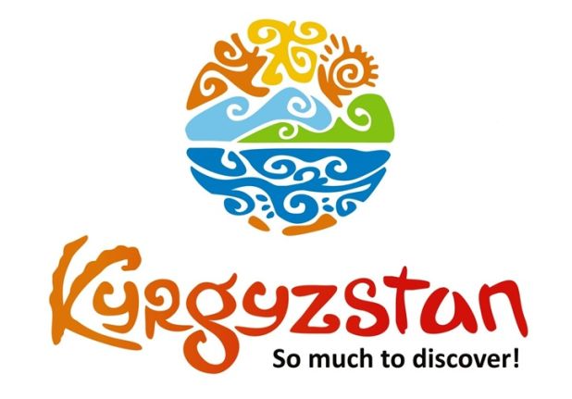**Tour to Sary-Chelek Lake for 3 days**

Country: **Kyrgyzstan**

Period: **May - September**

**Days: 3 / Nights: 2**

Organizing any complexity of tours to Issyk-Kul, Son-Kul, around Kyrgyzstan and Central Asia. We guarantee you high quality of service and individual approach!

Travel Cruiser offers a weekend tour to Sary-Chelek, one of the most beautiful lakes in the country! It is surrounded by walnut and fruit forests and more than 1000 species of plants, 160 species of birds. Additionally, 34 species of mammals (such as the deer, bear, lynx and wolf) can be found in this relatively small and unspoiled park. The views on the way to the lake are stunning and it is totally an Instagram-worthy place to travel!

The road wounds up and down several mountain passes above 3500 meter, before opening up to the green pastures of the Suusamyr valley where shepherds herd their flock. Then it takes visitors around the immense Toktogul reservoir down the deep Naryn River Gorge.

#### [Day 1: Bishkek – Sary-Chelek](https://concept.kg/en/tours/inbounds/24/#program_collapse_117)

Departure from Bishkek, drive through the beautiful Suusamyr Valley.  
Lunch (not included in the overall price) on the way to the Chychkan Gorge.  
Short break in Toktogul Reservoir.  
Arrival and dinner at homestay in Arkyt village.

Meals: no

#### [Day 2: Sary-Chelek Lake](https://concept.kg/en/tours/inbounds/24/#program_collapse_118)

After the breakfast, transfer to the Sary-Chelek Lake.  
Sary-Chelek is located in the center of the national reserve. Visitors can observe the diverse flora and fauna. This is one of the most beautiful lakes with rock formations that rise out of the water. The lake was formed because of a strong earthquake and it is the largest out of the 7 Lakes. Fresh water in Sary-Chelek is so clear that one can easily spot the multicolored small rocks on the bottom of the lake. Lake’s depth reaches 234 m, it extends to 2280 m in width and 7500 m in length.   
Hike around the lake or relax at the shore of the lake.  
Transfer back to a home stay. Dinner and overnight there.

Meals: breakfast

#### [Day 3: Sary-Chelek - Bishkek](https://concept.kg/en/tours/inbounds/24/#program_collapse_119)

Transfer back to the city of Bishkek.   
Arrival to Bishkek.

Meals: breakfast

| **Group Size** | **PRICE IN USD/PER PERSON** |
| --- | --- |
| 5 | 455 USD |
| 10 | 340 USD |
| 15 | 305 USD |

| **PRICE INCLUDES** |  |
| --- | --- |
| Accommodation | Homestay in Arkyt Village (2 nights) |
| Transportation | Included |
| Guide services (Eng/Russ) | Included |
| Meals | Mentioned in the program (only breakfasts) |
| Entrance fees | According to the program |

| **PRICE EXCLUDES** |
| --- |
| International/domestic flights |
| Personal expenses |
| Meals |
| Insurance |

**Contact information:**

[www.travelscruiser.com](http://www.travelscruiser.com)

Phone (24/7): +996 …………., +996 ……….

E-mail: [info@travelscruiser.com](mailto:info@travelscruiser.com)